DISPERSAL AREA
Section 35 Anti-Social Behaviour, Crime and Policing Act 2014

Under the authority of Inspector CORR you will be asked to leave the area (or part of the area) outlined in red in the map below if we have reasonable grounds to suspect that your behaviour in the locality has contributed or likely to have contributed to;

- members of the public in the locality being alarmed, harassed or distressed or;
- the occurrence in the locality of crime and disorder
And your removal is necessary to remove or reduce the above.

If the direction is given to a person who appears to be under 16 the officer may take them home or to a place of safety.

The dispersal authority commences at: 18:00 hours on: FRIDAY 19th JUNE 2026 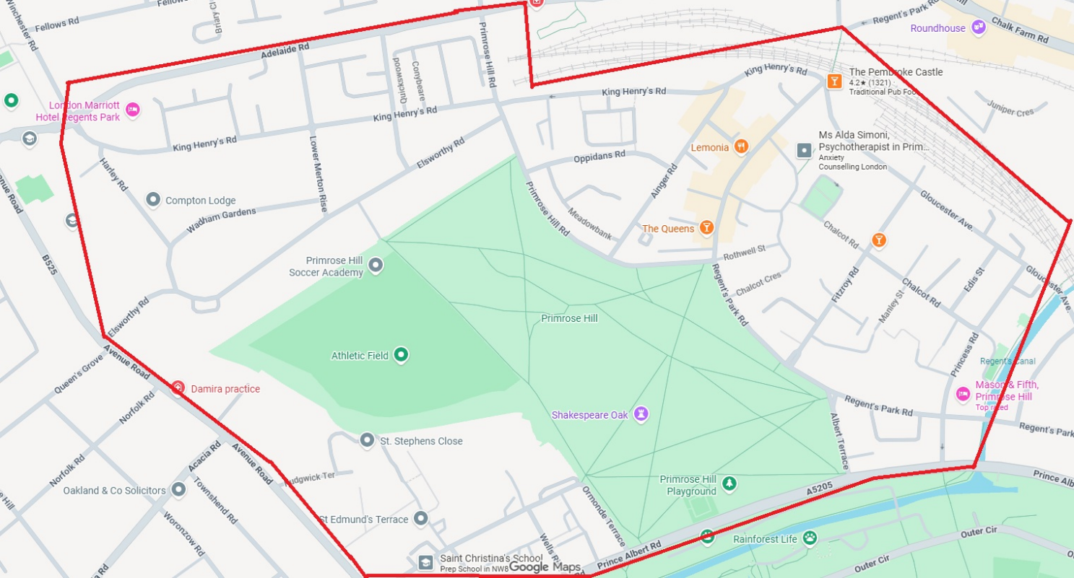
And ends at: 1800hrs hours on: SUNDAY 21st JUNE 2026

