North Richmond NEIGHBOURHOOD WATCH BRIEFING for APRIL 2026

This summary has been prepared to give an overview of the recorded crimes in North Richmond that are considered to be most relevant to the local community. It primarily focuses on acquisitive crime, however other incidents of note are also addressed as relevant.

Burglary
There was one recorded residential burglary in April, where the suspect has entered the home through a ground floor window, taking items, including car keys from inside and stealing the resident’s car.

There was one further recorded commercial burglary. It involved 2 suspects entering the shop and stealing products from behind the counter.

Theft from Motor Vehicles
There were 5 recorded thefts from motor vehicles in April, the primary means of entry was by smashing windows.

Theft of Motor Vehicles
One vehicle was reported stolen in April. The vehicle was keyless and parked outside of the owners address.

Crime Prevention Advice for Vehicles

- Park in well-lit, busy areas where possible
- Consider installing CCTV or using existing coverage
- Check whether your vehicle can be fitted with additional protective measures
- Report any suspicious activity to police

Theft of Bicycle

There were 4 reported thefts of bicycles in April, primarily occurring outside of shops.

All the bikes had been left secured with the lock broken.

NEXT POLICE LIAISON GROUP (PLG) MEETING:

The next PLG meeting will be in in July/August – Date and time TBC
It is your chance to meet officers from the local Police Safer Neighbourhood Team (SNT) officers who will provide updates on local crimes and policing issues. You also will be able to question the SNT and have a real input in the way that North Richmond is policed.
Local councillors also attend.

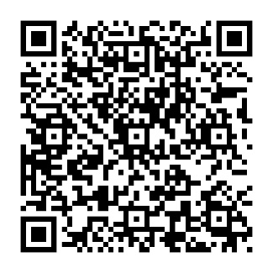
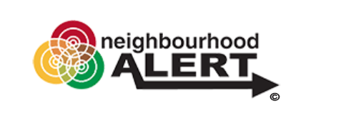

stay in the know with metengage
Want to hear directly from your local police team about what’s happening in your area?
METENGAGE is our new, free messaging service that lets you stay informed about local crime, policing updates, events and safety advice. You can even message us back, share concerns and help to shape the way we work In your community.

Sign up today – it only takes a few minutes, and it helps us keep you safer.

https://www.metengage.co.uk

Have your say in what matters locally.
Our Local Survey Matters survey gives you the opportunity to share your views and highlight the issues that are most important to you in your neighbourhood. Your input helps guide our focus and improve our service. Please scan the QR code to complete the survey.

