
Safer Neighbourhood Team
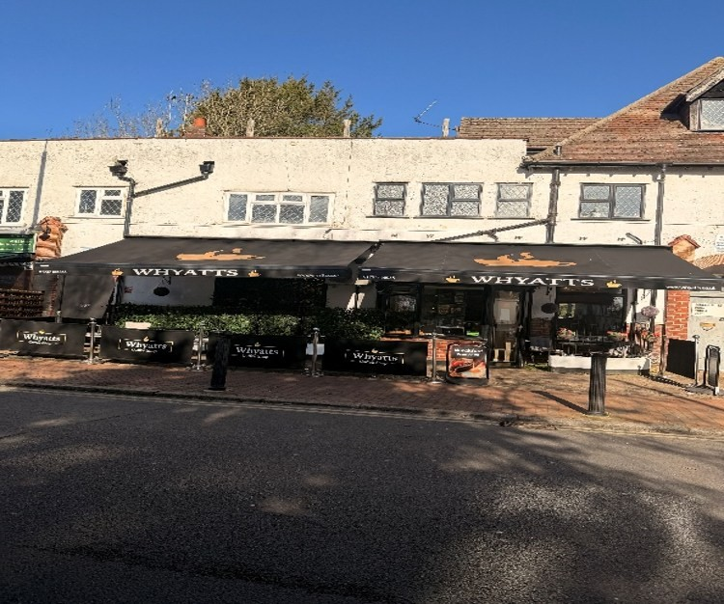
Old Coulsdon
Coffee with a Copper Dates
September 25th
11:00-12:00
27th of October
11:00-12:00
30th of November
11:00-12:00
Whyatts
1A The parade, Placehouse Lane,
Coulsdon Road, Coulsdon CR5 1EH
Come and join your local safer neighbourhood officers to discuss local crimes issues and get crime prevention advice tips while enjoying a cuppa.

