Safer Neighbourhood
Newsletter.
Welcome to April’s newsletter.

As the days grow milder and more inviting, you may find yourself spending more time outdoors, tidying the garden after the winter months. This also presents a great opportunity to check your property boundaries. Ensuring the outside of your property is secure not only helps protect valuables stored in sheds or garages, but also acts as a vital first line of defence against burglars attempting to access your home

- Keep hedges and walls at the front of your house low (under 1 metre) so burglars have nowhere to hide.
- Keep side gates always locked. Open gates mean burglars can easily access your home without being seen by passers-by or neighbours.
- Keep hedges, walls and fences around your back garden high (at least 1.8 metres). Add lightweight trellis to gates and fences and plant some prickly plants such as those on page 4 to make it harder for burglars to climb over.
- Gravel driveways and paths make it harder for burglars to go undetected.
- Install an outside dusk till dawn light so that intruders can't approach without being seen.
- Install a burglar alarm system from a National Security Inspectorate or Security Systems and Alarms Inspection Board member company.
- ﻿﻿Always keep your shed locked and secured; the shed should be firmly anchored down to stop it being lifted. Sheds are often used to store power tools and bicycles.
- ﻿﻿Never leave tools lying around as they can be used as a way of breaking into your home.

Extra steps you can take.

- ﻿﻿Consider buying a shed alarm. These are usually quite cheap but still effective.
- ﻿﻿Add an extra layer of protection to shed windows with laminate sheets of plastic security film or internal metal grills.
- ﻿﻿Contact your local planning office to find out how high your rear fence can be.

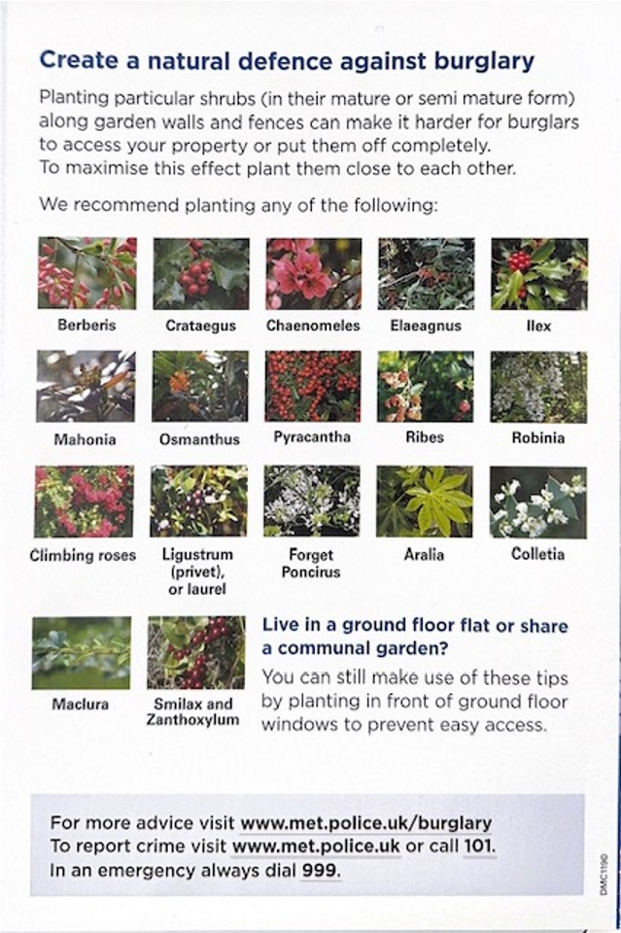

Burglary
There were 1 residential burglary, 1 attempted residential burglary, 0 non – residential burglaries, and 0 artifice burglaries reported in March.

Saturday 21st March 2026 at 3am

CARLTON AVENUE, N14

Three suspects entered the rear of property, stolen car key and car – Audi.

Tuesday 24th March 2026

PENNINGTON DRIVE, N21

Attempted aggravated – Four males attempted to access property by pushing occupier, suspects challenged who made off.

Motor Vehicle crime

There was 3 Theft from motor vehicle and 3 Theft of motor vehicles reported in March.

Friday 6th March 2026 at 1201am – 0800hrs

BELGRAVE GARDENS, N14

Mercedes stolen without keys

Wednesday 11th March 2026 at 9.35pm

GREYSTOKE GARDENS, EN2

suspect approached victim and said she needed to take her car to the garage, distracting her, while her purse and phone were stolen from inside the vehicle.

Wednesday 11th March 2026 8am – 5.55pm

OAKWOOD UNDERGROUND STATION car park,

Wing mirror stolen from BMW

Friday 13th March 2026

SHERINGHAM AVENUE, N14

Car logbook stolen from within.

Thursday 12th March 2026 3pm – 4pm

Banting Drive N21

Van stolen from location.

Friday 13th March 2026 140am – 7am

SOUTH LODGE DRIVE, N14

A6 stolen from driveway.

Robbery / Theft from person

There was 1 Theft from person, 1 Robbery and 1 commercial robbery reported in March

Friday 6th March 2026 at 1.30pm

Sainsburys Supermarket Highlands Village

Female has been distracted in SAINSBURY car park by the suspect, phone stolen from pocket.

Saturday 14th March 2026 5.50pm

PETROL STATION BRAMLEY ROAD, N14

The suspect entered the venue and stole fish and steak and pushed security guard.

Other Crimes in March 2026

2 x Criminal Damage

0 x ABH

1 x GBH

Are you interested in helping solve community problems and joining a joint task force that makes a positive difference to residents in your area? Join your ward panel meeting!

Every ward in London has a ward panel of local community members that meets with the ward Neighbourhood Policing Team four times a year. Meetings are held in person in the evenings at a local venue. At the ward panel meetings, members explain any community concerns, and the police provide information on crime, antisocial behaviour and their recent activity. The panel then sets the police team a minimum of two very specific priorities and actions to focus on in the ward and report back on at the next meeting. Meetings are also attended by the ward councillors, so that joint problem solving can be identified. The ward panel should be broadly representative of the ward. Members should live, work or study in the ward. They should be able to communicate community concerns to the police and share information widely in the community.

Anyone is welcome, but we are specifically looking to recruit members that are active in any Neighbourhood Watch or WhatsApp groups that are willing to be spokespeople for their respective areas so that we can hear the issues that are affecting you!

If you would like to join, please contact us - the next meeting is Tuesday 2nd June at St Thomas Church, Prince George Avenue, N14 at 7pm.

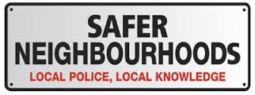

Team Members

Based at Enfield Patrol Base, Great Cambridge Road

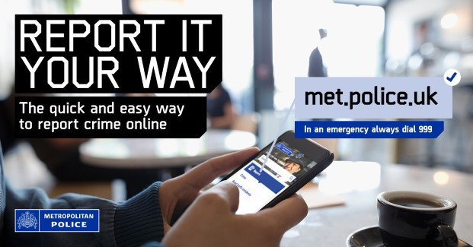
Industrial Estate, Lincoln Road EN1

Your Dedicated Ward Officers (DWOs) on Oakwood Ward

are:

Supervisor

PS Ken Carroll

Dedicated Ward Officers:

PC Jacob Brett

PC King Eze

PCSO Kauna Oliveria

PCSO Lisa Simpson

Email: Oakwood@met.police.uk

We encourage residents to reach out to police via telephoning 999 if something is actively occurring at the time or 101 if you observe something out of place.

Nearest police station
Edmonton Police station
462 Fore Street, Edmonton N9 0PW
Opening hours –
Weekday 10am – 10pm
Weekend 9am – 7pm

Remember: To report a crime:
- Non-emergency crime: dial 101 or report online
- Report anonymously via crimestoppers-uk.org or by calling 0800 555 1111



Stay informed with Met Engage
Get the latest updates from the Met straight to your inbox.
Met Engage is a free messaging service that keeps you connected to what’s happening in your area. Whether its crime updates, safety advice, or news from your local policing team, you’ll get the information that matters to you — when it matters most.


Why sign up?
When you join Met Engage, you’ll receive:
- alerts about local crime, incidents and appeals
- advice to help keep you, your family and your community safe
- news from your local police officers
- warnings about scams and frauds
- invitations to community meetings and events
- chances to share your concerns and help shape local policing
How to sign up
Signing up takes just a few minutes and you can update your preferences at any time. Your information is secure, and we’ll only use it to send you relevant updates.
By signing up at the link below, you'll join thousands of others who are already receiving trusted updates from their local police.
https://www.metengage.co.uk/

