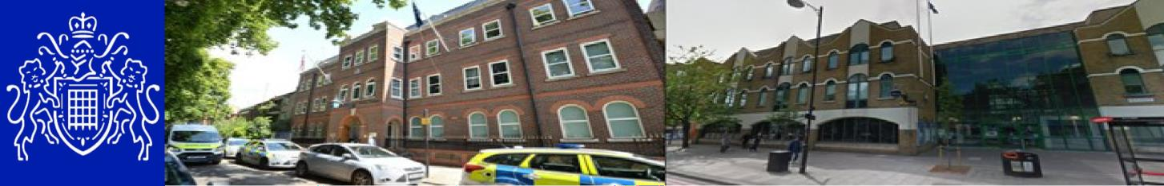
Central East BCU — Bow East SNT Safer Neighborhood Newsletter February 2026


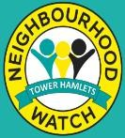
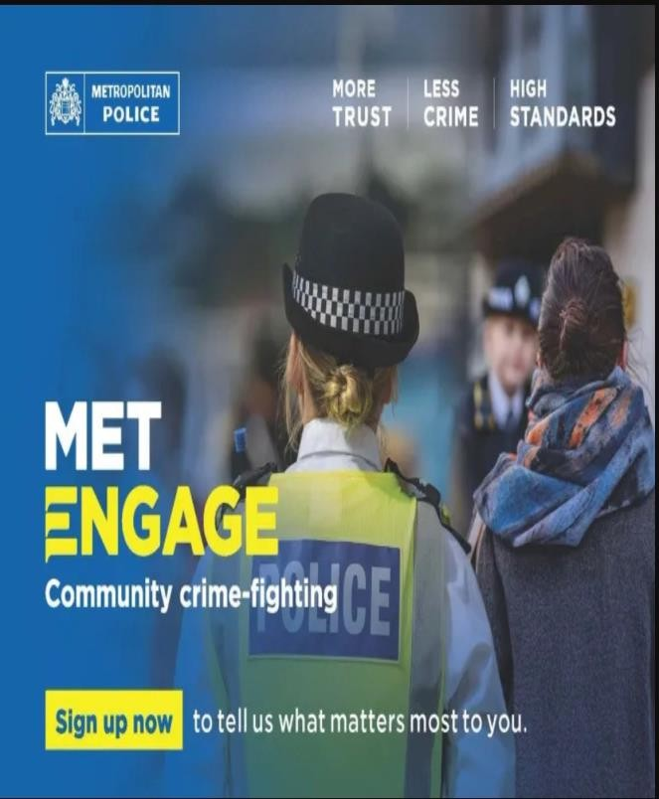
Your Safer Neighborhood Team

Your Local SNT teams are overseen by

PS CHAMBERS
Bow East
PC Gray, PC McCarthy, PC Guelfi, PC Jarasiute,
PCSO Das, PCSO Christopher, PCSO Iftkhar, PCSO D’Imperio

Safer Neighborhood Officers conduct regular highly visible patrols across the ward to deter and disrupt criminal activity and anti-social behavior. They also hold regular crime prevention events, public contact sessions and community meetings to hear about the issues that matter most to you

Contact us
Your Safer Neighborhood Ward phone, email and Social media accounts are NOT monitored 24/7 and are NOT intended for the public to re- port crimes on, instead please use the non- emergency number 101 or complete and online report.

IN AN EMERGENCY DIAL 999

Bow East SNT contact us:
CEMailbox.BowEast@Met.Police.uk
Social Media

MET ENGAGE:
Get the most out of your neighborhood with MET ENGAGE. It's where communities come together, exchange recommendations. Read the latest local news and be made aware of upcoming events from public services.
Register with MET ENGAGE:

www.metengage.co.uk
Sign Up for Met Engage & complete the Local Area survey at: https://survey.metengage.co.uk

Neighborhood Watch
To find out what groups are active in your area and to register to join London Borough of Tower Hamlets | Neighborhood Watch Network (ourwatch.org.uk)

Central East BCU — Bow East SNT
Safer Neighborhood Newsletter February 2026
Community Engagement / Action:  You Said: There are bike thefts along Fish Island.  We did: Recently we have conducted a Bike Marking Event at Barge East, E9.  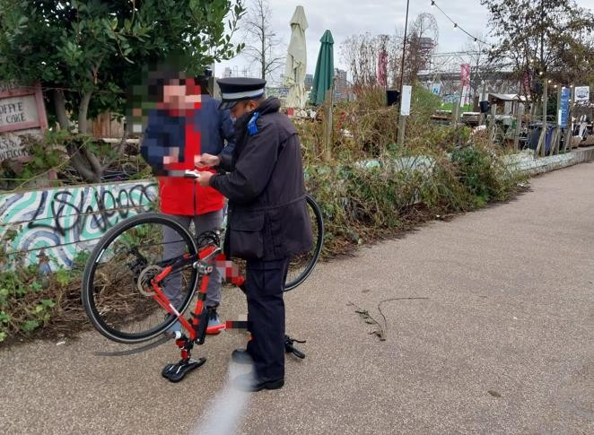  Officers from Bow East SNT successfully carried out a joint School patrol along with Spit & Bang SNT on Tuesday 10th February 2026, location at Langdon Park School, St Leonards Road, E14.  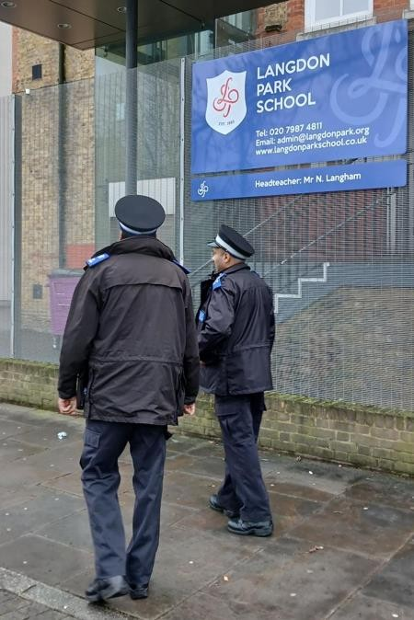 |  | Violence against women and girls (VAWG) walk and talk Bow East SNT conducted VAWG event at The Hub Cafe-E3. Crime prevention & safety advice was provided to residents, shopkeepers and visitors.  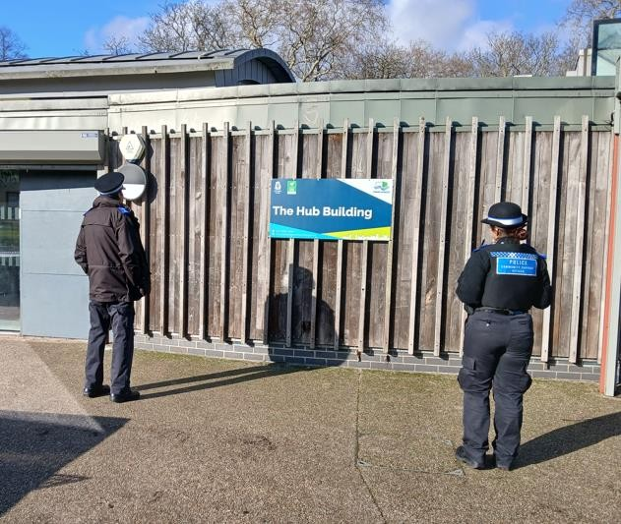  BOW EAST SNT Officers conducted High Visible Patrol in and around the Mostyn Grove, E3.  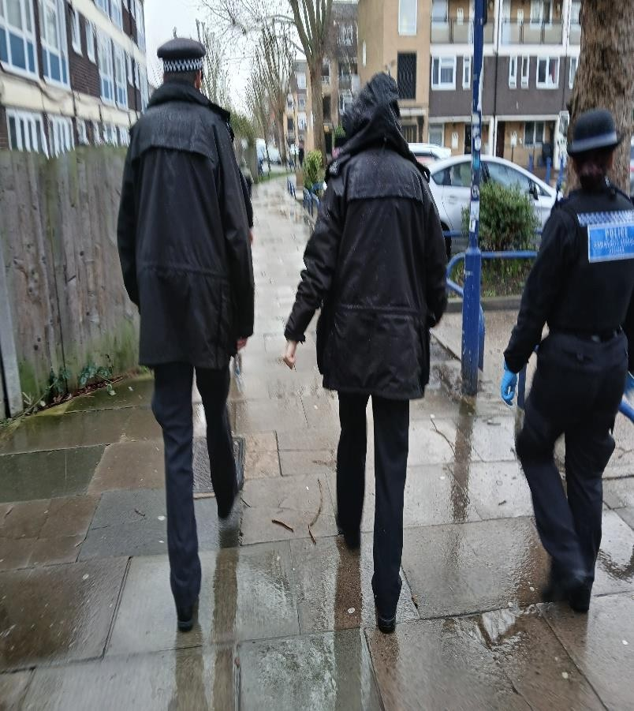



Central East BCU — Bow East SNT Safer Neighborhood Newsletter February 2026

Crime in Your Area
If you have a problem in your area but don’t want to talk to Police, Contact Crime Stoppers or Fearless.
Crime type | Tower Hamlets | Bow East
Theft and Handling | 779 | 39
Violence | 771 | 43
Burglary | 211 | 11
Drugs | 173 | 12
Criminal Damage | 136 | 10
Robbery | 94 | 5
Sex offences | 101 | 6
Miscellaneous | 33 | 2

These organizations are confidential, and you will not be asked for your details.
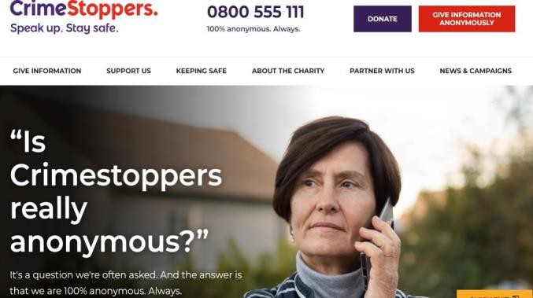

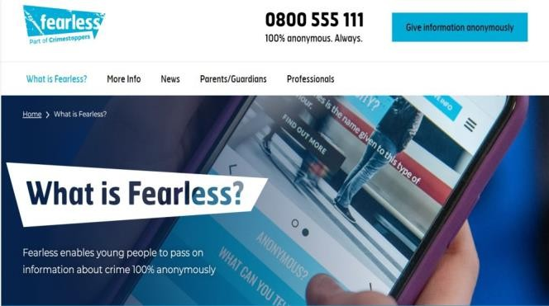
Number of Crimes in your Area – February 2026 For a more in-depth statistics and data for London please visit
https://www.met.police.uk/sd/stats-and-data

Upcoming Events
Bike marking scheme:
Bike Marking Event
11:00AM - 12:00AM, Wednesday 4 March 2026 Rookwood Way E3 2YZ
VAWG Events:
VAWG (Violence against Women & girls) Event 13:00 PM – 14:00 PM, Mon 27 April 2026,
location: St Stephens State, E3
Dates Are Subject to change / Cancellation subject to Staff availability.

