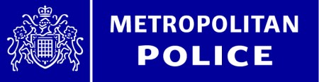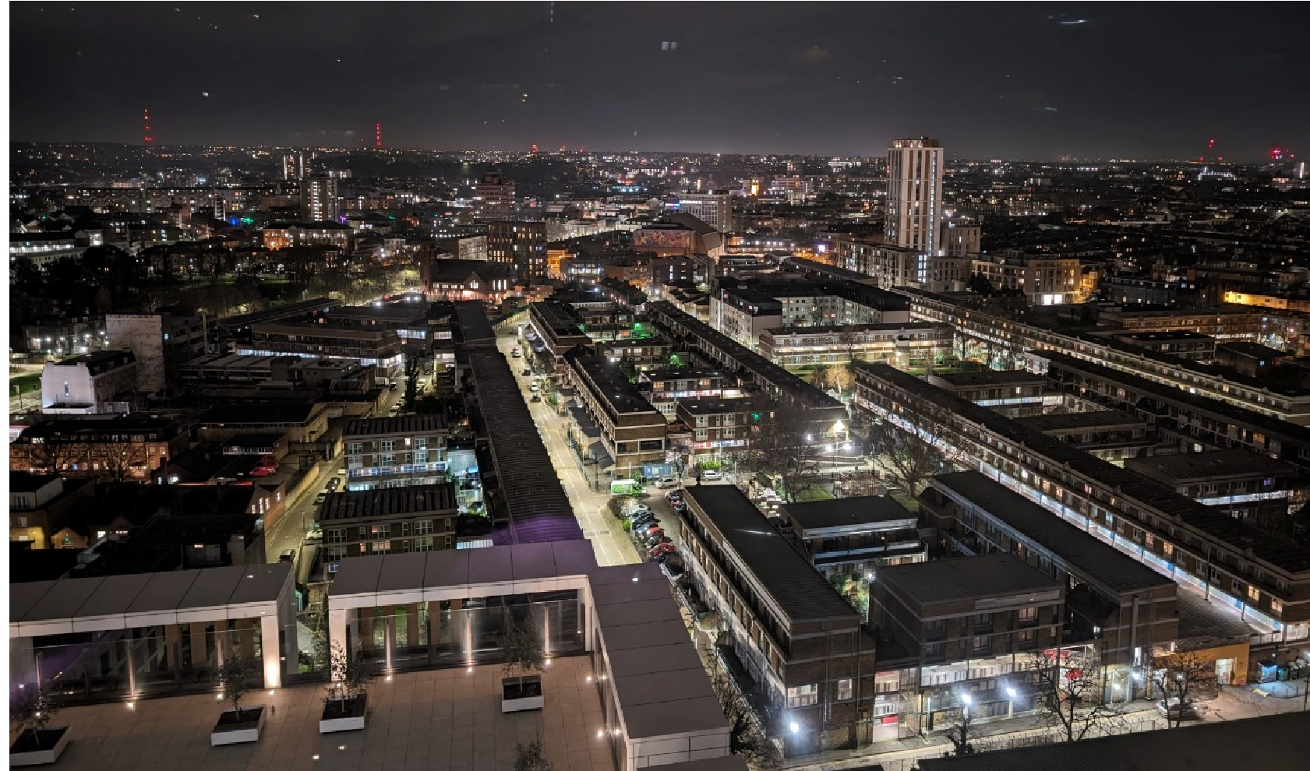
Brixton North

July ward panel

We invite you to our Brixton North ward panel meeting on the 16th of July 2026 and is being hosted at Angell Town RMO’s Office, Overton Rd, SW9 7HN
It will start at 6.30pm and will finish at 8.30pm.
We are working hard to tackle the issues that matter to you working with partner agencies to find solutions. Our quarterly meeting sets key priorities for the dedicated Neighbourhood Police Team. The Team will be there to answer questions. If you cannot attend, you can contact them on the below email address.

Contact Us: BrixtonNorth@met.police.uk



