Safer Neighbourhood
Newsletter.
Welcome to April’s newsletter.

As the days grow milder and more inviting, you may find yourself spending more time outdoors, tidying the garden after the winter months. This also presents a great opportunity to check your property boundaries. Ensuring the outside of your property is secure not only helps protect valuables stored in sheds or garages, but also acts as a vital first line of defence against burglars attempting to access your home

- Keep hedges and walls at the front of your house low (under 1 metre) so burglars have nowhere to hide.
- Keep side gates always locked. Open gates mean burglars can easily access your home without being seen by passers-by or neighbours.
- Keep hedges, walls and fences around your back garden high (at least 1.8 metres). Add lightweight trellis to gates and fences and plant some prickly plants such as those on page 4 to make it harder for burglars to climb over.
- Gravel driveways and paths make it harder for burglars to go undetected.
- Install an outside dusk till dawn light so that intruders can't approach without being seen.
- Install a burglar alarm system from a National Security Inspectorate or Security Systems and Alarms Inspection Board member company.
- ﻿﻿Always keep your shed locked and secured; the shed should be firmly anchored down to stop it being lifted. Sheds are often used to store power tools and bicycles.
- ﻿﻿Never leave tools lying around as they can be used as a way of breaking into your home.

Extra steps you can take.

- ﻿﻿Consider buying a shed alarm. These are usually quite cheap but still effective.
- ﻿﻿Add an extra layer of protection to shed windows with laminate sheets of plastic security film or internal metal grills.
- ﻿﻿Contact your local planning office to find out how high your rear fence can be.

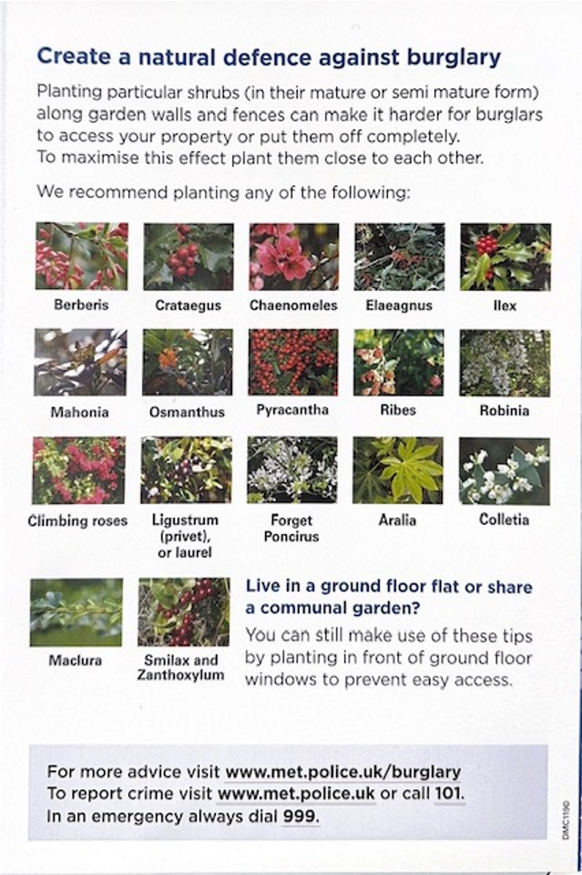

MV = Motor Vehicle Crime
VWI = Victim With Injury (Assault)

Burglary
- There were 2 residential burglaries, 2 attempted
residential burglary, 1 non – residential burglaries,
reported in March 2026.

- MINCHENDEN CRESCENT. N14. 25th March 2026. Time 02:13 - 02:16. Hrs. Suspect has forced front door open, whilst victim was asleep and stolen a bag with bank cards, car keys, and IDs in it. Van stolen.

- CRANFORD AVENUE. N13. 26th March 2026. Time between 19:00 – 07:00 Hrs. The venue is a house under renovation that has been gutted and being worked on by builders. Power tools left in the address overnight have been stolen. The property was secured by one padlock.

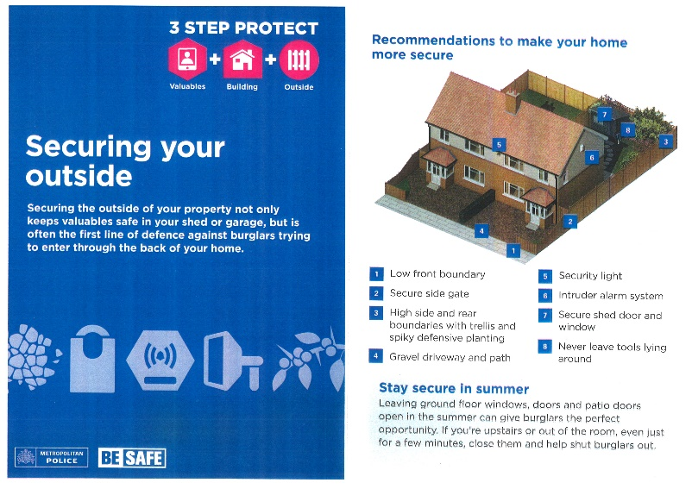

Attempted Burglary.

- RAVENSCRAIG ROAD N11. 05th March 2026. Time 20:00 Hrs.The victims were in the living room watching TV when they heard loud banging (3-5 bangs) at the front door.
- FORESTDALE. N14. 16th March 2026. Time approximately 21:15 Hrs. Suspect/s have attempted to pry open the front patio door with tools. Disturbed due to victims having been at home. Front door damaged.

Motor Vehicle crime

There were 2 Theft of motor vehicle and 2 Theft from motor vehicles reported in March.

- WATERFALL ROAD N11. 19th March 2026. Reported on 23rd March. Vehicle involved in an accident and left for recovery, stolen whilst recovery is arranged. HONDA CIVIC.

- CHANDOS AVENUE, N14. 26th March 2026. Time between 00:52 Hrs. and 01:10 Hrs. Vehicle stolen from victim’s home. Ring doorbell shows the car was there at 01:00. NISSAN JUKE.

- FOXGROVE. N14. 13th March 2026. Victim reporting unknown suspects have taken all documents relating to the car from my glovebox including my logbook and all service documents. As well as a small amount of change that was hidden in the front armrest. HYUNDAI

- LANGSIDE CRESCENT. N14. 19th March 2026. Time 13:17 Hrs. Unknown suspect has stolen the catalytic converter from victim’s motor vehicle. Victim has advised that there is no CCTV at scene No items of forensic value left behind by suspect.

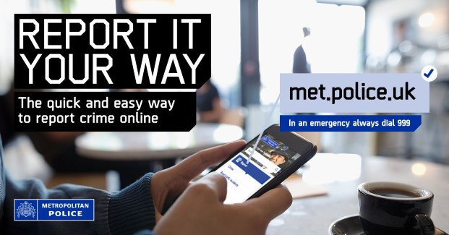

Are you interested in helping solve community problems and joining a joint task force that makes a positive difference to residents in your area? Join your ward panel meeting!

Every ward in London has a ward panel of local community members that meets with the ward Neighbourhood Policing Team four times a year. Meetings are held in person in the evenings at a local venue. At the ward panel meetings, members explain any community concerns, and the police provide information on crime, antisocial behaviour and their recent activity. The panel then sets the police team a minimum of two very specific priorities and actions to focus on in the ward and report back on at the next meeting. Meetings are also attended by the ward councillors, so that joint problem solving can be identified.
The ward panel should be broadly representative of the ward. Members should live, work or study in the ward.

They should be able to communicate community concerns to the police and share information widely in the community.

Anyone is welcome, but we are specifically looking to recruit members that are active in any Neighbourhood Watch or WhatsApp groups that are willing to be spokespeople for their respective areas so that we can hear the issues that are affecting you!

If you would like to join, please contact us - the next meeting is Tuesday 9th June at Beaumont Hall on Canon Road. N14 at 7pm.

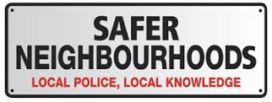

Team Members

Based at Enfield Patrol Base, Great Cambridge Road

Your Dedicated Ward Officers (DWOs) on Arnos Grove Ward

are:

Supervisor

PS Erin Emin

Dedicated Ward Officers:

PC Callum Blatchford

PC Gani Bajrami

PCSO Nusrat Fayyaz

Email: Arnosgrovesnt@met.police.uk

We encourage residents to reach out to police via telephoning 999 if something is actively occurring at the time or 101 if you observe something out of place.

Nearest police station
Edmonton Police station
462 Fore Street, Edmonton N9 0PW

The Safer Neighbourhoods Team (SNT) held a community engagement event at Arnos Grove Park, which was very well attended. Many residents came along, interacted positively with officers, and shared local concerns and feedback.
We will continue to host monthly community events, and all future dates and details will be shared on Met Engagement to keep residents fully informed.

Stay informed with Met Engage
Get the latest updates from the Met straight to your inbox.
Met Engage is a free messaging service that keeps you connected to what’s happening in your area. Whether its crime updates, safety advice, or news from your local policing team, you’ll get the information that matters to you — when it matters most.


Why sign up?
When you join Met Engage, you’ll receive:
- alerts about local crime, incidents and appeals
- advice to help keep you, your family and your community safe
- news from your local police officers
- warnings about scams and frauds
- invitations to community meetings and events
- chances to share your concerns and help shape local policing
How to sign up
Signing up takes just a few minutes and you can update your preferences at any time. Your information is secure, and we’ll only use it to send you relevant updates.

By signing up at the link below, you'll join thousands of others who are already receiving trusted updates from their local police

