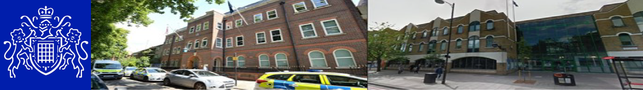
Central East BCU — Bow East SNT
Safer Neighbourhood Newsletter July 2026


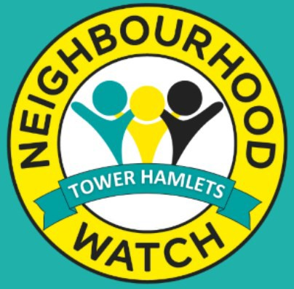
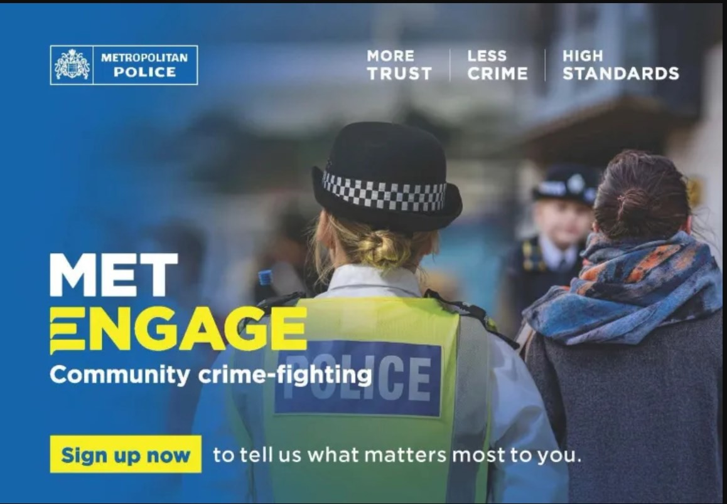
Your Safer Neighbourhood Team

Your Local SNT teams are overseen by PS Chambers
Bow East
PC McCarthy, PC Guelfi,
PC Jarasiute, PC Evans, PCSO Das,
PCSO Christopher, PCSO Iftkhar

Safer Neighbourhood Officers conduct regular highly visible patrols across the ward to deter and disrupt criminal activity and anti-social behaviour. They also hold regular crime prevention events, public contact sessions and community meetings to hear about the issues that matter most to you

Contact us
Your Safer Neighbourhood Ward, email and Social media accounts are NOT monitored 24/7 and are NOT intended for the public to re- port crimes on, instead please use the non-
emergency number 101 or complete and online report .

IN AN EMERGENCY DIAL 999

Bow East SNT contact us: CEMailbox.BowEast@Met.Police.uk

Social Media

MET ENGAGE :
Get the most out of your neighborhood with MET ENGAGE. It's where communities come together, exchange recommendations. Read the latest local
news and be made aware of upcoming events from public services.
Register with MET ENGAGE :

www.metengage.co.uk
Sign Up for Met Engage & complete the Local Area survey at: https://survey.metengage.co.uk

Neighbourhood Watch
Neighbourhood Watch is about people getting to-
gether with their neighbours to take action to reduce crime. They work by developing a close relationship between community members and the local Police. To find out what groups are active in your area and to register to join London Borough of Tower Hamlets | Neighbourhood Watch Network (ourwatch.org.uk)



Central East BCU — Bow East SNT
Safer Neighbourhood Newsletter July 2026

Bow East SNT held a weapon sweep in Victoria park and in Brodick house and the surrounding area.

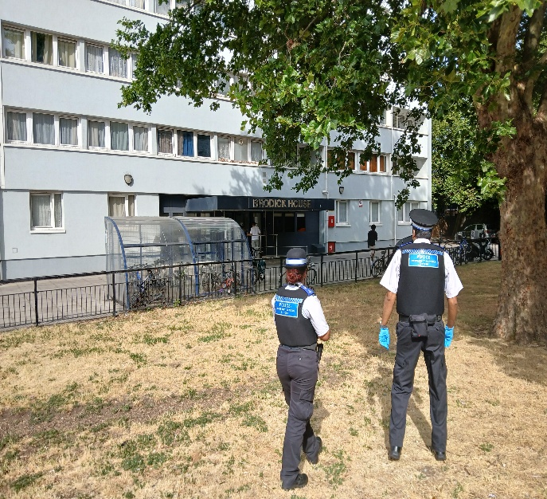

Officers from BOW EAST SNT carried out high visibility burglary patrols in Fish Island, crime prevention advice given to residence, spoke to the businesses around the area.
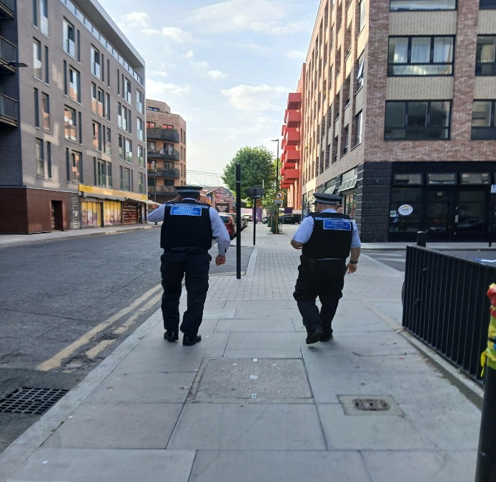

You said: ASB in Matilda Garden
We did: Bow East SNT carried out High visibility patrols in the area

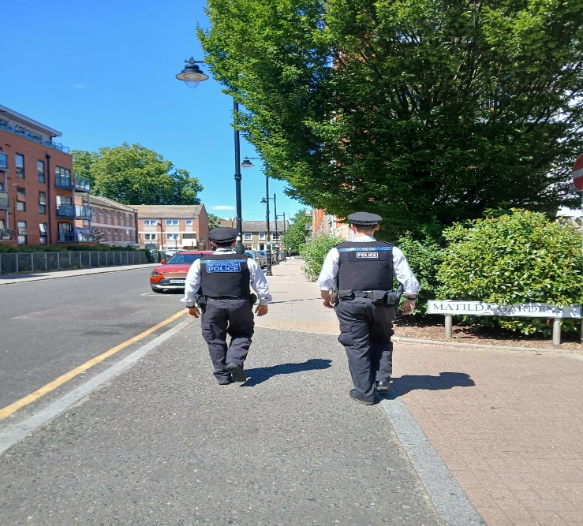

Violence against women and girls (VAWG) walk and talk Bow East SNT conducted VAWG event at Hackney Wick and Barge EAST. Crime prevention & safety advice was provided to residents, and visitors.
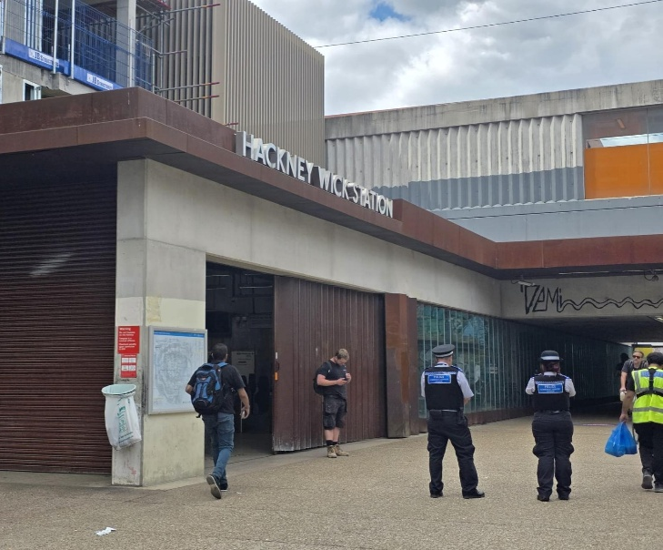
Central East BCU — Bow East SNT
Safer Neighbourhood Newsletter July 2026

Crime in Your Area
If you have a problem in your area but don’t want to talk to Police, Contact Crime Stoppers or Fearless.
These organizations are confidential and you will not be asked for your details.

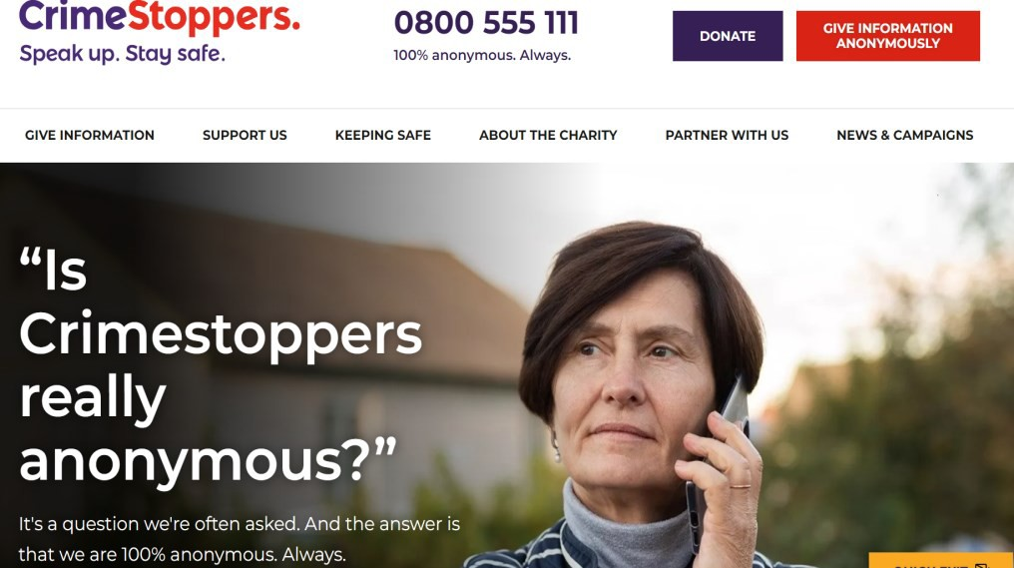

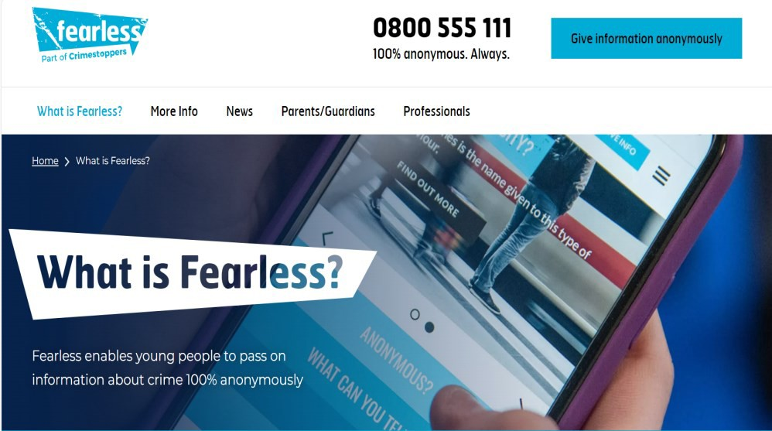

Number of Crimes in your Area—July 2026 For a more in depth statistics and data for London please visit
https://www.met.police.uk/sd/stats-and-data

Crime type | Tower Hamlets | Bow East
Theft and  Handling | 1069 | 53
Violence | 1046 | 58
Burglary | 200 | 19
Drugs | 209 | 11
Criminal Damage | 180 | 7
Robbery | 121 | 8
Sexual offences | 99 | 4
Miscellaneous | 45 | 3

Upcoming Events

Ward panel meeting:
Thursday 03 September 2026 at 1800 hrs at
1 Gladstone Mews E3

VAWG event:
Friday 21 August 2026 at 1600 hrs at
Barge East E9

between community members and the local Police. To find out what groups are active in your area and to register to join London Borough of Tower Hamlets | Neighbourhood Watch Network (ourwatch.org.uk)

