Safer Neighbourhood Newsletter.
Welcome to May newsletter.

Going on holiday is an exciting time and something that we all look forward to. However, before going away on holiday you need to think about the security of your home, as returning home from a holiday to find out that your home has been burgled would be both upsetting and stressful.
Follow the advice below to help keep your home safe while you're away

- Ensure the locks on all windows and doors are in good working order and are locked. If you are replacing a broken or defective lock, or looking to improve the security of existing doorsets or windows, a Locksmith registered with the Master Locksmiths Association can specify the best & most secure lock to use for your type of door or window.
- Remove the keys from all windows and doors and put them in a safe place when you leave the house
- If you have an intruder alarm, make sure it’s set. If you don’t have one consider having an approved alarm system installed.
- Make use of smart light bulbs or timer plugs with lamps and radios to make your house seem occupied. You can also get photosensitive bulbs, which are activated when it gets darker
- Don’t leave valuable items such as laptops and jewellery in view of windows.
- Lock valuable items away in a ground anchored safe or you could consider leaving important documents and valuable items with other family members whilst away
- Don’t forget the outside of your home too. It is important that your home does not appear unoccupied whilst you are away, so consider cutting the lawn and hedges before you leave, so that it doesn’t look unkempt.
- Make sure all access points are secured such as gates and activate any external security lighting.
- Ensure gardening equipment, tools and ladders are put away and securely stored. Don’t leave them lying around in your garden as they could aid burglars
- Ensure that any sheds and outbuildings are locked and secured.
- Cancel milk and newspaper deliveries if you have them. Don’t announce your departure to a shop full of people. Only tell people who need to know you’re going away such as a trusted friend or neighbour
- Ask a trusted neighbour or friend to collect post, open and close curtains
- Never post statuses or comment on social media about going on holiday – or indeed whilst you are away on holiday. You wouldn’t display a sign in your window advertising that you’re going on holiday, so don’t advertise it online - if you must post status updates, ensure that your privacy settings are set so that only trusted family and friends can view the updates

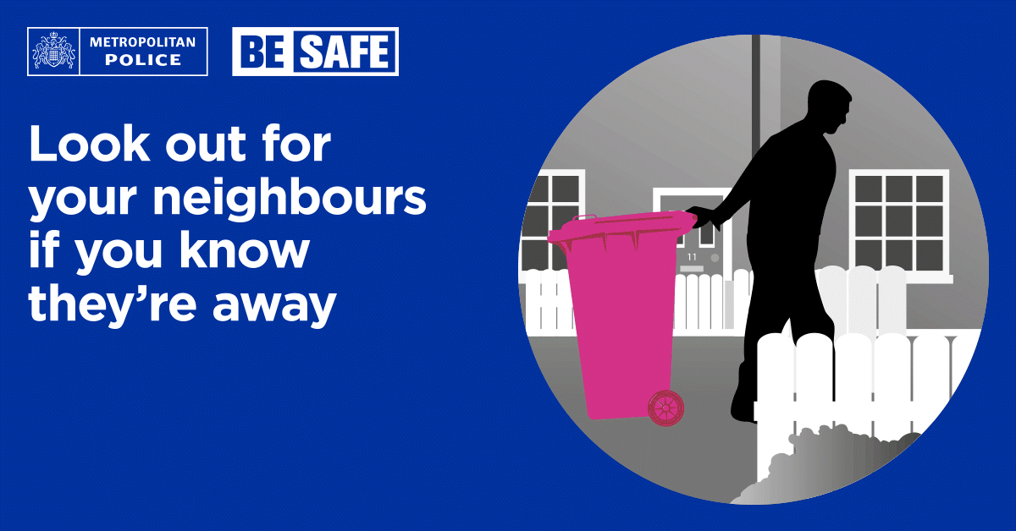

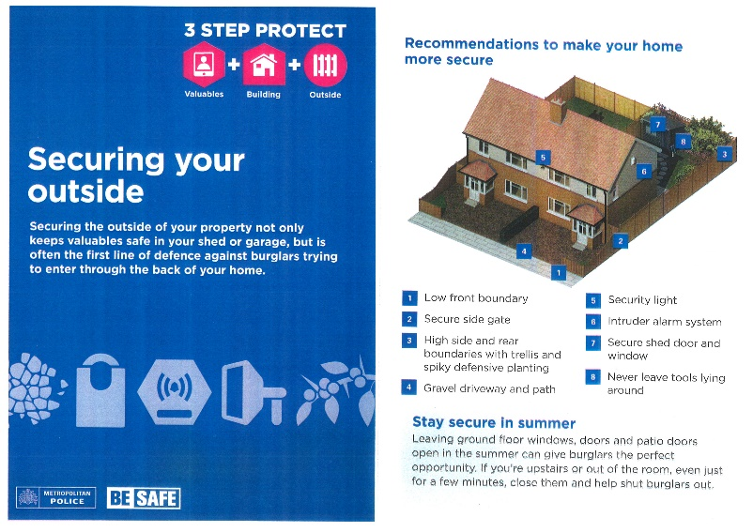
Burglary
There were 1 residential burglary, 0 attempted residential burglary, 0 non – residential burglaries, and 0 artifice burglaries reported in April.

MONDAY 13TH APRIL 2026 at 6.55pm

CULGAITH GARDENS, EN2

Suspect gained access through rear patio door.
Motor Vehicle crime

There was 0 Theft from motor vehicle and 1 Theft of motor vehicles reported in April.

THURSDAY 16TH APRIL 2026 at 5.15pm

BRAMLEY ROAD N14

Keyless Range Rover Stolen

VWI = Victim with Injury (Assault
MV = Motor Vehicle Crime

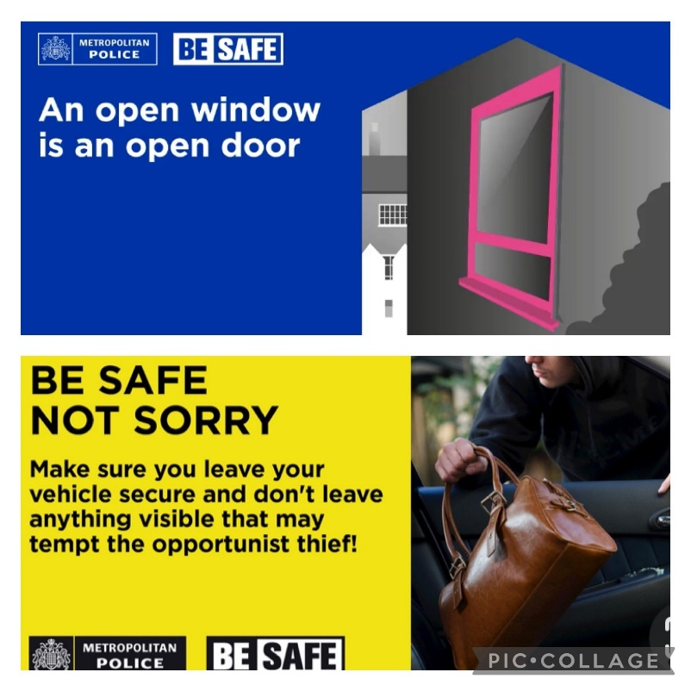

Robbery / Theft from person

There was 1 Theft from person and 1 Robbery

reported in April.

TUESDAY 21ST APRIL 2026

CHASE ROAD, N14 at 2.38pm

A male suspect approached the victim from behind, threatened the victim with a knife. Attempted to take her bag and proceeded to take her phone before making off on the e-bike from the scene.

SATURDAY 4TH APRIL 2026

OAKWOOD TUBE STATION 7pm

Mobile phone stolen from person at the bus stop outside Oakwood Tube Station, Suspect was on an electric scooter

Other Crimes in April

1 x criminal damage

4 x ABH

0 x GBH
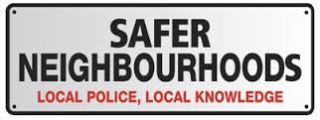

Team Members

Based at Enfield Patrol Base, Great Cambridge Road

Industrial Estate, Lincoln Road EN1

Your Dedicated Ward Officers (DWOs) on Oakwood Ward

are:

Supervisor

PS Ken Carroll

Dedicated Ward Officers:

PC Jacob Brett

PCSO Kauana Oliveria

PCSO Lisa Simpson

Email: Oakwood@met.police.uk
We encourage residents to reach out to police via telephoning 999 if something is actively occurring at the time or 101 if you observe something out of place.
Remember: To report a crime:
- Non-emergency crime: dial 101 or report online
- Report anonymously via crimestoppers-uk.org or by calling 0800 555 1111

Nearest police station
Edmonton Police station
462 Fore Street, Edmonton N9 0PW
Opening hours –
Weekday 10am – 10pm
Weekend 9am – 7pm


Stay informed with Met Engage
Get the latest updates from the Met straight to your inbox.
Met Engage is a free messaging service that keeps you connected to what’s happening in your area. Whether its crime updates, safety advice, or news from your local policing team, you’ll get the information that matters to you — when it matters most.


Why sign up?
When you join Met Engage, you’ll receive:
- alerts about local crime, incidents and appeals
- advice to help keep you, your family and your community safe
- news from your local police officers
- warnings about scams and frauds
- invitations to community meetings and events
- chances to share your concerns and help shape local policing
How to sign up
Signing up takes just a few minutes and you can update your preferences at any time. Your information is secure, and we’ll only use it to send you relevant updates.
By signing up at the link below, you'll join thousands of others who are already receiving trusted updates from their local police.
https://www.metengage.co.uk/

