Barkingside SNT would like to invite residents to the following
18th June, Gateway Community Church,39 Woodford Avenue, IG2 6UH,3-4pm
18th June ward panel meeting, Barkingside police station,1High Street,IG6 1QB,18:30pm.

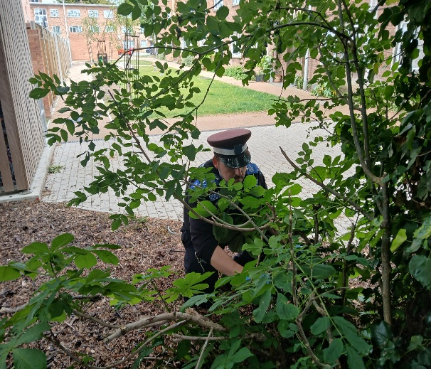
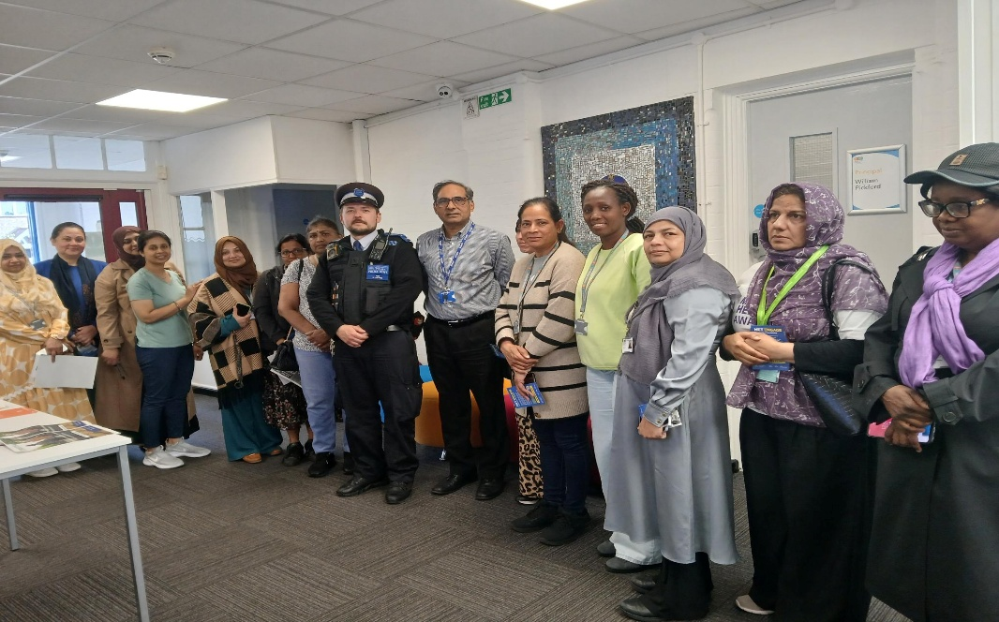
Barkingside SNT
PS383EA Catherine Brindley McEvoy, PC 1940EA Omar PEREIRA, PC1441EA Dean TITCOMBE, PCSO Martin KADLUBIEC 7005EA
Please sign up to new police platform met Engagement www.metengage.co.uk
@MPSbarkingside Twitter(X) account is no longer in use
@MPSRedbridge Twitter account is still in use



Ward events
Some of what we been up to……
www.met.police.uk
Mobile - 07917013339
101 in non-emergency – 999 in emergency
- Reassurance patrols @ Little Gearies
- Op Sceptre -weapon sweep
- Stop and search
- Arrest enquiries
- Ward priorities patrols
- VAWG walk, talks and due.
- Targeted shoplifting at Gants Hill
- Promoting new met Engagement platform
- Get in touch www.metengage.co.uk
www.met.police.uk
Mobile - 0208 721 2567
Crime stoppers call anonymously – 0800 555 111
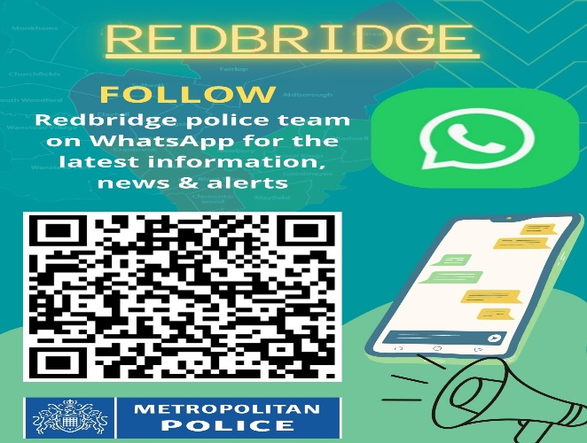

June 2026
Redbridge WhatsApp

We listened and have upped our foot patrols in Barkingside
BARKINGSIDE SNT – NEWSLETTER- June 2026

Barkingside Ward Newsletter June 2026 – Community Update

Safer Neighbourhood Team Update
The Barkingside Safer Neighbourhood Team (SNT) continues to work closely with residents, schools, faith groups, and local businesses across the ward. Our focus remains on visibility, engagement, reassurance, and addressing community concerns.

High Visibility & Reassurance Patrols
Officers have carried out regular high-visibility and reassurance patrols across Barkingside Ward at varied times of day and evening. Patrol locations are informed by local reports, community feedback, and intelligence.
Recent patrol areas include:
- North Cross Road
- Parham Drive / City Gate House
- Campbell Avenue
- Hatley Avenue
- Little Gearies
- Gants Hill and surrounding roads
These patrols provide reassurance, deter offending, and allow officers to engage directly with residents.

Good News – Positive Police Action
Barkingside Safer Neighbourhood Team continues to proactively tackle drug-related offences within the ward.
- 13th May – Redbridge Lane South:
Officers conducted a stop under Section 23 Misuse of Drugs Act, resulting in cocaine being found. The suspect was arrested at the scene.
- 27th May – Eastern Avenue:
During a vehicle stop, officers again utilised Section 23 Misuse of Drugs Act powers, leading to the discovery of cocaine. The suspect was subsequently arrested.
These positive outcomes highlight our continued efforts to disrupt drug-related activity, remove illegal substances from our streets, and keep Barkingside a safe place for everyone.

Violence Against Women and Girls (VAWG)
As part of our ongoing commitment to tackling Violence Against Women and Girls, officers completed a Walk, Talk and Do within the ward. Residents were encouraged to share concerns, discuss personal safety, and highlight areas where they feel less safe. Feedback received will inform future patrol planning.

Working Together
Information and feedback provided by the community continues to shape our policing priorities. Working together remains key to keeping Barkingside safe and welcoming.

Stay Informed
Thank you to everyone who has taken the time to speak with our officers. We encourage residents to sign up to Met Engage for local updates, crime prevention advice, and information about neighbourhood policing activity.

BARKINGSIDE WARD – COMMUNITY SAFETY UPDATE
Over recent days, Barkingside Safer Neighbourhood Team (SNT) has been actively engaging with our community to provide reassurance, prevention advice, and visible policing across the ward.
Following recent tragic events, officers carried out reassurance visits to local places of worship, including the synagogue and mosque within Barkingside. This comes after a serious attack near a synagogue in Golders Green, which caused significant concern within the community, as well as a tragic incident in San Diego, USA, where a mosque was targeted, resulting in loss of life and injuries. We recognise the impact such incidents can have locally, and our presence is to offer support, reassurance, and maintain strong community relationships.
Officers have also been focusing on motor vehicle crime prevention, which remains a priority within the ward. SNT officers conducted leaflet drops providing residents with practical advice on how to protect their vehicles—particularly keyless cars—from theft. This includes guidance such as using steering locks, storing keys in signal-blocking pouches, and remaining vigilant to suspicious activity.
In addition, high-visibility patrols have been carried out across key locations in Barkingside in line with our ward priorities. These patrols are aimed at deterring crime, increasing reassurance, and maintaining a visible and approachable policing presence.
We encourage residents to continue working closely with us—please report any concerns, remain vigilant, and take simple steps to protect yourselves and your property.
Barkingside SNT remains committed to keeping our community safe, supported, and united.

Community Message
We would like to take this opportunity to congratulate the Barkingside Ward Councillors on their successful election and wish them all the very best in their roles serving the community.
We would also like to thank our residents for their continued support and cooperation. We encourage everyone to remain vigilant, report any concerns, and continue working with us to keep Barkingside a safe and welcoming place for all.

