Safer Neighbourhood News
Welcome to the August Newsletter.

Welcome to the August 2026 EN2 Ward Crime Newsletter.
This newsletter provides residents with an overview of crime reported across the ward during July and highlights emerging trends, notable incidents and crime prevention advice. Keeping our community informed helps residents remain aware of local issues and supports our collective efforts to make EN2 a safer place to live, work and visit.

During July, the ward experienced low levels of overall crime, with no reports of robbery, theft from person or violence with injury offences. However, theft of motor vehicles remains the most significant concern, accounting for the highest number of offences recorded throughout the month. There were also a small number of burglaries and criminal damage incidents reported.

We would like to thank residents for their continued vigilance and support. Information provided by the community plays a vital role in helping police identify offenders, prevent crime and protect local neighbourhoods. We encourage everyone to remain alert, review their home and vehicle security measures, and continue reporting suspicious activity to police.

MV = Motor Vehicle Crime
VWI = Victim With Injury (Assault)

EN2 Crime Summary (Period Ending 31 July 2026)
Overall recorded crime across the monitored categories reduced during July 2026, with 17 crimes recorded compared to 22 in June. Motor vehicle crime continued to account for the largest proportion of offences, while burglary levels remained relatively low throughout the month.

Burglary
Total offences: 4 burglaries during July
- 03/07: Attempted residential burglary at Winsmoor Court, Glebe Avenue. Suspects attempted to gain entry but were disturbed by a CCTV alarm and left without causing damage or stealing property.
- 14/07: Residential burglary at Trentwood Side. Suspects gained entry via the rear of the property and were seen leaving with suspected stolen items before making off in a vehicle.
- 16/07: Burglary at a construction site on The Ridgeway. Suspect(s) entered the site and stole an airless pump from the basement area.
- 22/07: Burglary at Englefield Close. A garage was entered without damage being caused to the lock, property was stolen, and the garage was secured again upon departure.
- 31/07: No further burglaries recorded.
Key Themes
- Residential properties continue to be targeted via rear access points.
- Commercial and garage burglaries remain present but at low levels.
- No aggravated or artifice burglaries were recorded during the month.

Robbery
Total offences: 0 robberies
No robbery offences were recorded during the reporting period.
Key Themes
- No personal or commercial robberies reported.
- Continued positive trend with robbery remaining at very low levels.

Theft from Person
Total offences: 0
No theft from person offences were recorded during the reporting period.

Motor Vehicle Crime
Total offences: 9
This remains the most significant crime category during July.
Theft from Motor Vehicle (0 offences)
- No thefts from motor vehicles were reported during July.
Theft of Motor Vehicle (9 offences)
- Vehicles stolen from Spring Court Road, The Ridgeway and Old Park Road between 3 and 4 July.
- Vehicle stolen from Lavender Hill on 7 July.
- White Luton van stolen from Slades Rise on 7 July.
- Scooter stolen from outside a business on Windmill Hill on 12 July.
- Vehicle stolen from Chase Green Avenue on 13 July.
- Vehicle stolen during a private sale at Marian Mews on 16 July after the suspect drove off with the vehicle.
- Vehicle stolen from Gresham Close on 22 July.
Key Themes
- Vehicle theft remains the highest-volume offence type on the ward.
- Residential streets and vehicles left outside properties continue to be targeted.
- One vehicle was stolen during a private sale, highlighting the need for caution when meeting prospective buyers.

Criminal Damage
Total offences: 4
- 19/07: Vehicle damaged following an argument at Shanti Close.
- 20/07: Mobile phone damaged following a verbal dispute at Langton Court, The Ridgeway.
- 27/07: Vehicle tyres punctured at Old Park View.
- 29/07: Damage Property- ring doorbell camera
Key Themes
- Low levels of criminal damage overall.
- Two of the three incidents involved damage to vehicles or vehicle-related property.

Violence with Injury
Total offences: 0
No Violence with Injury offences, including GBH, ABH or domestic violence with injury, were recorded during the reporting period.

Monthly Assessment
Areas of Concern
- Motor vehicle crime remains the primary crime issue across the ward.
- Vehicles continue to be stolen from residential roads and outside home addresses.
- Offenders are targeting a variety of vehicle types, including cars, vans and motorcycles.

Other Incidents
Attempted Vehicle Theft 1
- 13/07: Chase Green Avenue, EN2. A suspect entered a victim's vehicle and attempted to steal it. The victim disturbed the offender during the attempt, causing the suspect to flee the scene on foot. This incident highlights the continued risk of vehicle-related offending within the ward and the importance of ensuring vehicles are locked and secured at all times.
Positive Findings
- No robberies recorded.
- No Theft from Person offences recorded.
- No Violence with Injury offences recorded.
- Overall crime reduced from 22 offences in June to 17 in July.
- Burglary levels remained relatively low with four offences throughout the month.

Recommended Crime Prevention Messages
- Ensure vehicles are locked and secured at all times and consider additional security devices such as steering wheel locks and immobilisers.
- Store vehicle keys away from doors and use signal-blocking pouches for keyless vehicles.
- Check CCTV, alarm systems and exterior lighting are fully operational.
- Report suspicious activity promptly via 101 or 999 in an emergency.

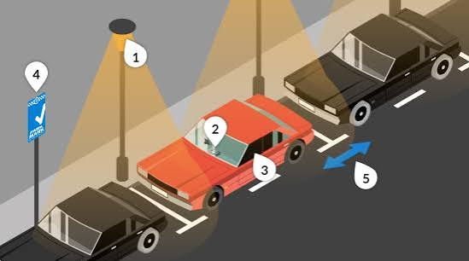
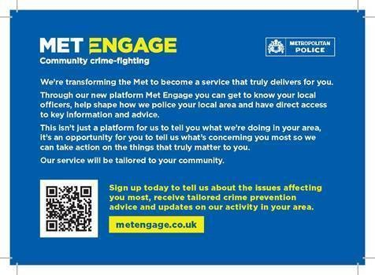

Through our new platform Met Engage you can get to know your local officers, help shape how we police your local area and have direct access to key information and advice.

This is not just a platform for us to tell you what we are doing in your area, it's an opportunity for you to tell us what's concerning you most so we can act on the things that truly matter to you.

https://www.metengage.co.uk/



YOU CAN STILL CONTACT US AS BELOW

Team Members

Based at Enfield Patrol Base your

Dedicated Ward Officers (DWOs) on

Ridgeway Ward are:

Supervisor

PS Alex Kane

Dedicated Ward Officers:

PCSO Deb Anjan

PCSO Agachi Simona

Email: ridgeway@met.police.uk

If you wish to report a crime you must always use
101 for non-emergency matters.
Always dial 999 in an emergency.

Useful Contacts
24/7 Police Station
Edmonton Police station
462 Fore Street, Edmonton N9 0PW

