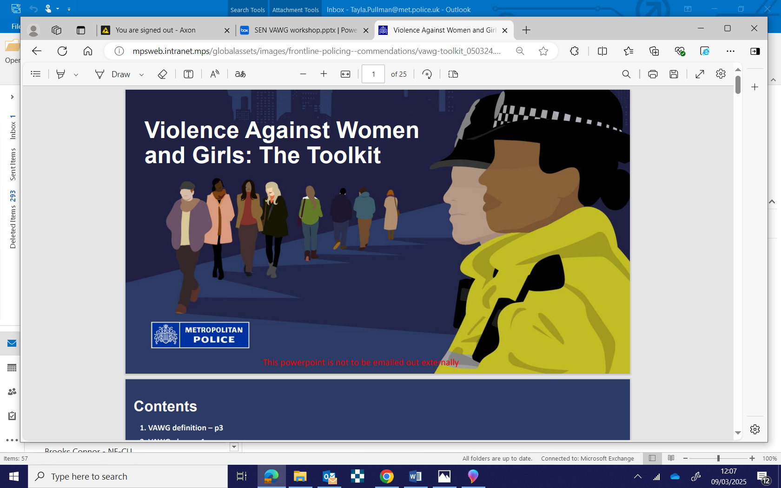
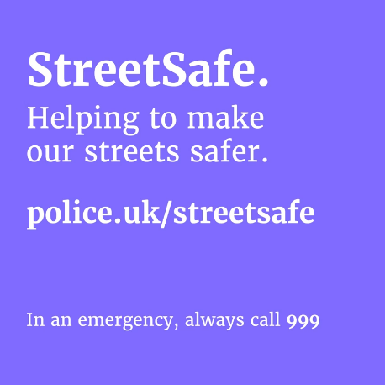
Women’s Safety Walk & Talk
An opportunity to speak to your local Officers:
Come and join your local safer neighbourhood officers in a walk & talk to discuss issues relating to violence against women and girls in the local area.
Tuesday 28th JULY 2026 @ 5PM
Meeting point –
HOLLOW PONDS BOATING Lake, Boat House ,
E11 1NW

