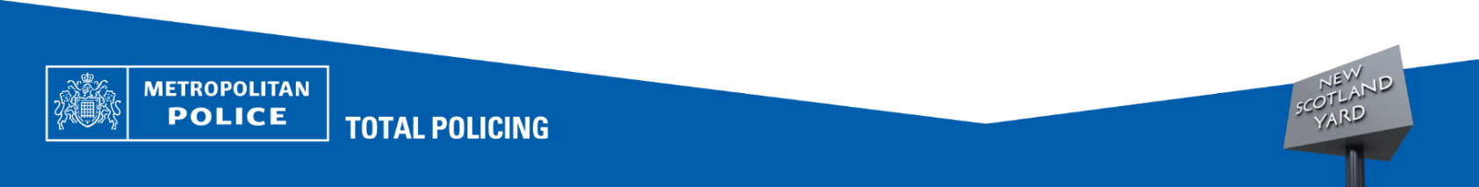





if you see suspicious activity:
REPORT IT IMMEDIATELY:
- 999 – Emergency /crime in progress
- 101 – Non-emergency
- report online via your local police website: www.met.police.uk

We are reminding residents to remain alert following reports of distraction theft incidents in the area.
Distraction thieves often work in pairs or groups, using a variety of tactics to gain entry to your home or divert your attention – such as posing as officials, asking for help, or creating a false emergency. Similar tactics are also used when you’re out shopping or going to a cash point.

Protect yourself and your home – Crime Prevention Advice

- STAY AWARE OF YOUR SURROUNDINGS:
Avoid becoming distracted by mobile phones or headphones in busy areas.

- KEEP BELONGINGS SECURE:
Use zipped bags and keep them closed. Carry bags in front of you in crowded places.

- BE CAUTIOUS OF STRANGERS APPROACHING YOU:
Especially if they invade your personal space or try to distract you.

- AVOID DISPLAYING HIGH VALUE ITEMS:
Limit use of expensive jewellery or electronics in crowded areas.

- USE CONTACTLESS PAYMENTS WISELY:
Shield your pin and be mindful when using cards in public.

- PLAN AHEAD:
Know your route and avoid unnecessary stops where you may be more vulnerable.

- TRUST YOUR INSTINCTS:
If something feels wrong, move away and seek help.
If something feels wrong, move away and seek help 
Police Advisory!

