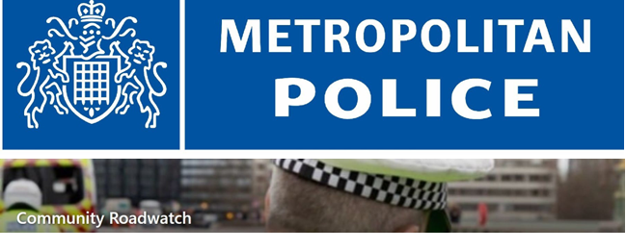

Community Road Watch Volunteers Needed

The Safer Neighbourhoods Team is bringing Community Road Watch back to our streets to help tackle dangerous and anti-social driving in our neighbourhood.

As part of our ongoing Community Crime Fighting Initiative, we would like to invite residents who are interested in supporting this project to get involved.

Community Road Watch gives local volunteers the opportunity to work alongside the police to identify and address speeding and unsafe driving, helping to make our roads safer for everyone.

If you would like to be considered for participation in this initiative, please forward your expression of interest to us. Further details regarding training and deployment will be provided. This is mainly addressed to all those over the age of 18.

Register your interest at SNT PL - Crofton Park <sntpl-.croftonparkMPS@met.police.uk> and you will be contacted with further details.

Community Roadwatch (CRW) teams are groups of local people who volunteer their time to help keep their communities safe in partnership with the Police. Their aims are to:
- Reduce death and serious injury on the roads
- Improve the quality of life for their local communities
- Reduce the speed of vehicles to the speed limit
- Increase public awareness of inappropriate speed

What happens next?

Drivers are not prosecuted or fined as a direct result of CRW activity, but we hope that they are deterred from choosing illegal speeds in the future. The report will be held on our Community Roadwatch records for 12 months. If this behaviour is reported again we will treat it as a deliberate decision to break the law, and we will take appropriate action. We are working in partnership with the Metropolitan Police Service (MPS) and City of London Police (CoLP) to run Community Roadwatch - a road safety initiative which aims to reduce speeding in residential areas.

