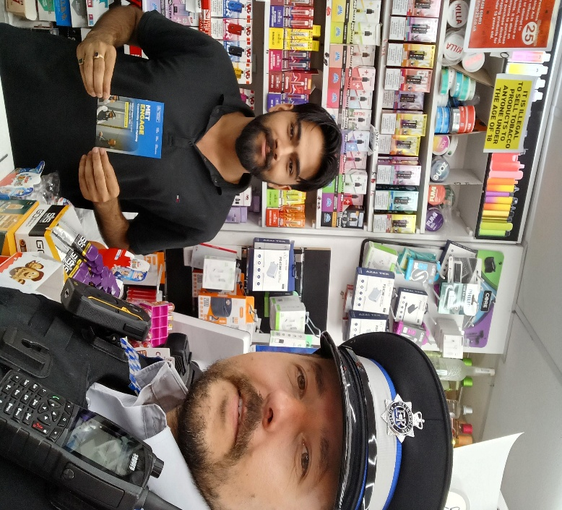
Barkingside SNT would like to invite residents to the following
30th August,VAWG, Violence against women’s and girls’ safety Walk talk and do, meeting point outside Black Moon bar, Seven ways Parade, IG2 6JX,4-5pm
.

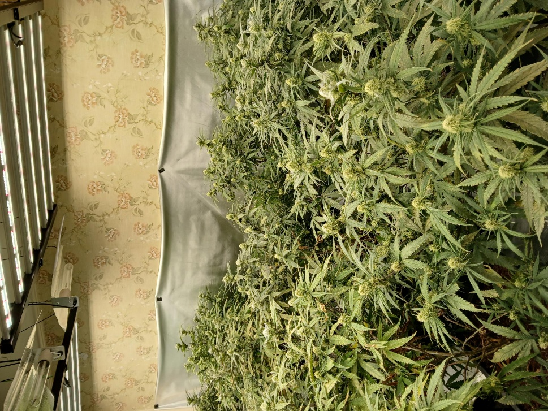
Barkingside SNT
PS383EA Catherine Brindley McEvoy, PC 1940EA Omar PEREIRA, PC1441EA Dean TITCOMBE, PCSO Martin KADLUBIEC 7005EA
Please sign up to new police platform met Engagement www.metengage.co.uk
@MPSbarkingside Twitter(X) account is no longer in use
@MPSRedbridge Twitter account is still in use



Ward events
Some of what we been up to……
www.met.police.uk
Mobile - 07917013339
101 in non-emergency – 999 in emergency
- Reassurance patrols @ Little Gearies ,Inglehurst Garden .
- Cannabis factory taken down on Fullwell ward.
- Stop and search
- Arrest enquiries
- Ward priorities patrols
- VAWG walk, talks and due.
- Targeted shoplifting at Gants Hill
- Promoting new met Engagement platform
- Get in touch www.metengage.co.uk
www.met.police.uk
Mobile - 0208 721 2567
Crime stoppers call anonymously – 0800 555 111
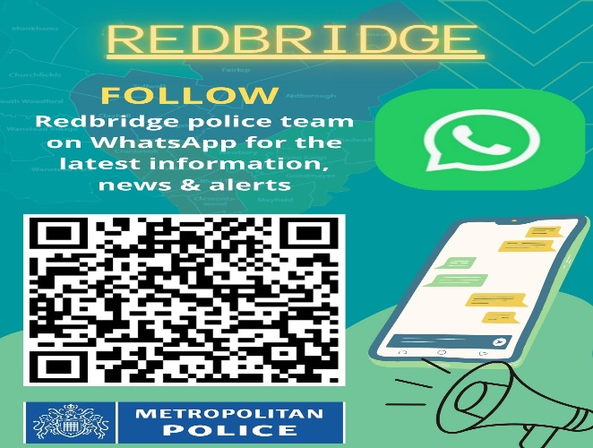

August 2026
Redbridge WhatsApp

We listened and have upped our foot patrols in Barkingside
BARKINGSIDE SNT – NEWSLETTER- August 2026
Barkingside Ward Newsletter
August 2026 Community Update
Dear Residents,
The Barkingside Safer Neighbourhood Team (SNT) continues to work closely with residents, faith groups, schools, and local businesses to keep our community safe. Our focus remains on visible policing, crime prevention, engagement, and addressing local concerns.

Shoplifting Prevention Operation
On 4 August 2026, Barkingside and Clayhall SNT officers conducted a joint plain-clothes operation at the Co-op store on Longwood Gardens to deter shoplifting and identify offenders.
During the operation, officers identified a male known for persistent begging and anti-social behaviour in the Eastern Avenue. He was subsequently issued with a Community Protection Warning (CPW).
The Longwood Gardens Co-op continues to be one of the most targeted retail locations for shoplifting within the local area. As a result, officers are carrying out regular plain-clothes operations to deter offenders, gather intelligence, and make arrests where appropriate. These proactive operations will continue over the coming months.

High Visibility and Reassurance Patrols
Officers have continued to conduct high-visibility patrols across Barkingside Ward at various times of the day and evening. Recent patrol locations include:
- Gants Hill
- Wycombe Road
- Woodford Avenue
- Little Gearies
- Cranbrook Road
- Longwood Gardens
These patrols help deter criminal activity, provide reassurance to residents, and allow officers to engage directly with members of the community. Patrol locations continue to be informed by local intelligence, reports from residents, and ward priorities.

Tackling Drug-Related Crime
Barkingside SNT remains committed to tackling drug-related offences within the ward. Working alongside neighbouring teams, officers recently conducted a joint patrol with Fullwell SNT, which led to the identification and closure of a suspected cannabis factory.
This positive result demonstrates our ongoing commitment to disrupting criminal activity, safeguarding local communities, and working proactively to address issues that impact residents' safety and quality of life.

Violence Against Women and Girls (VAWG)
As part of our ongoing commitment to tackling Violence Against Women and Girls, Barkingside SNT has scheduled a number of Walk, Talk and Do events around the Gants Hill area. These events provide an opportunity for residents to discuss personal safety concerns and identify locations where they feel vulnerable.
We encourage everyone to attend and share their views. Details of upcoming events and community contact sessions can be found on:
www.met.police.uk

Community Reassurance and Crime Prevention
Following recent incidents that have caused concern within communities nationally and internationally, officers have carried out reassurance visits to local places of worship across the ward. Maintaining strong relationships with all communities remains a key priority for Barkingside SNT.
Officers have also continued providing crime prevention advice relating to vehicle crime, including guidance on protecting keyless vehicles from theft. Residents are encouraged to consider using steering wheel locks, signal-blocking pouches, and to report any suspicious activity.

Working Together
Information provided by residents continues to shape our policing priorities. Barkingside SNT remains committed to taking reports seriously and responding appropriately and promptly to concerns raised by the community.
Thank you to everyone who continues to engage with us and support local policing initiatives.

Community Message
Finally, we would like to extend our best wishes to everyone celebrating the upcoming Indian Independence Day and Pakistan Independence Day. We hope you enjoy a safe, peaceful, and enjoyable celebration with your families and communities.
Best wishes,
Barkingside Safer Neighbourhood Team
Metropolitan Police Service

