Safer Neighbourhood News
Welcome to the October 2026 Newsletter

This newsletter provides residents with an overview of crime reported across the ward during September 2026 and highlights emerging trends, notable incidents and crime prevention advice. Keeping our community informed helps residents remain aware of local issues and supports our collective efforts to make EN2 a safer place to live, work and visit.
During September, burglary remained the highest recorded crime category, with several offences occurring at business and community premises, particularly at Chase Farm Hospital. Motor vehicle crime also remained a concern, with several vehicle thefts reported throughout the month. Robbery, criminal damage and violence with injury remained at comparatively low levels, although domestic-related assaults accounted for all violence with injury offences recorded during the reporting period.
We would like to thank residents for their continued vigilance and support. Information provided by the community plays a vital role in helping police identify offenders, prevent crime and protect local neighbourhoods. We encourage everyone to remain alert, review their home and vehicle security measures, and continue reporting suspicious activity to police.


EN2 Crime Summary
Period Ending 30 September 2026
A total of 15 offences were recorded across the monitored crime categories during September 2026. Burglary accounted for the largest proportion of offences, with 5 incidents reported throughout the month. Motor vehicle crime accounted for 4 offences, while robbery, criminal damage and violence with injury remained comparatively low.
MV = Motor Vehicle Crime
VWI = Violence With Injury

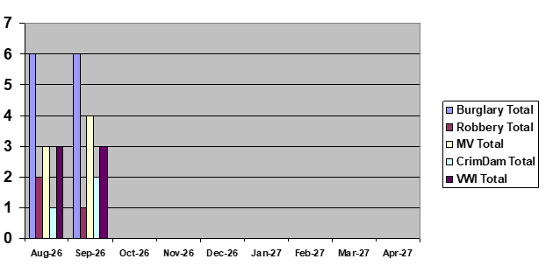
Burglary
Total offences: 5 burglaries during September
Residential Burglary
- 14/09 - Hadley Road, EN2: A neighbour reported a property with the front door left open and hallway light on. Police attended and established the property was vacant and unfurnished. Examination revealed that entry had been forced by prising open the front door using a tool.
Attempted Residential Burglary
- 17/09 - Milne House, Uplands Park Road, EN2: Unknown suspect(s) attempted to gain entry to a residential property. Damage was caused to the front door; however, access was not gained and nothing was stolen.
Business and Community Burglary
- 09/09 - Chase Farm Hospital, The Ridgeway, EN2: Damage was caused to a door lock and several keys were reported stolen. Several vans were also reported stolen from the premises.
- 11/09 - Chase Farm Hospital, The Ridgeway, EN2: Four suspects gained entry to a staff office within a mental health ward. Security staff attended and the suspects fled the scene.
- 25/09 - Chase Farm Hospital, The Ridgeway, EN2: Offenders damaged a compound fence and stole company equipment from within the secured area.

Robbery
Total offences: 1 robbery
Incident
- 02/09 - Hedge Hill, EN2: Attempted robbery reported at a local store. No injuries were reported.

Theft From Person
Total offences: 0
No theft from person offences were recorded during September.

Motor Vehicle Crime
Total offences: 4
Theft of Motor Vehicle
- 02/09 - John Gooch Drive, EN2: Unknown suspect(s) stole a vehicle from outside the victim's address. The vehicle was subsequently located through a tracking system and recovered by the owner.
- 08/09 - The Ridgeway, EN2: A vehicle was stolen from a friend's driveway. The vehicle had been declared off-road and the keys remained in the owner's possession.
- 15/09 - The Grove, EN2: A van was stolen by unknown suspect(s).
Theft From Motor Vehicle
- 23/09 - Fairmead Lodge, The Ridgeway, EN2: The front registration plate was stolen from a parked vehicle.
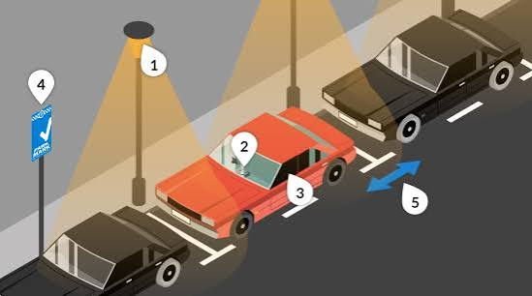

Criminal Damage
Total offences: 2
Incidents
- 12/09 - Woodridge Close, EN2: A shed was deliberately set on fire, causing damage.
- 26/09 - Chasewood Avenue, EN2: Criminal damage was caused to a motor vehicle.

Violence With Injury
Total offences: 3
Incidents
- 09/09 - The Ridgeway, EN2: Domestic-related Assault Occasioning Actual Bodily Harm (ABH).
- 23/09 - Sefton Court, The Ridgeway, EN2: Domestic-related ABH reported.
- 30/09 - Roundhedge Way, EN2: Domestic-related ABH reported.

Incident of Note
Vehicle Interference - Prevented by Vehicle Security
- 09/09 - The Grove, EN2
Two suspects arrived in a vehicle and stopped alongside a parked van. The suspects attempted to gain entry by cutting into the van's door. However, the vehicle had been fitted with deadlocks which successfully prevented access. No entry was gained and no property was stolen.
This incident highlights the effectiveness of additional vehicle security measures such as deadlocks, alarms and tracking devices in preventing theft and protecting valuable tools and equipment.

Monthly Assessment
Areas of Concern
- Burglary was the highest-volume offence category during September.
- Chase Farm Hospital experienced multiple burglary-related incidents throughout the month.
- Motor vehicles, particularly vans, continued to be targeted by offenders.
- Domestic violence accounted for all Violence With Injury offences recorded during the reporting period.
- The attempted interference of a van demonstrates that tradespeople's vehicles remain attractive targets for criminals.
Community Impact
Crime levels across EN2 remained relatively low during September. However, repeat incidents at commercial locations and the continued targeting of vehicles highlight the need for residents and businesses to remain vigilant. Effective security measures, prompt reporting and community awareness continue to play a key role in preventing crime and identifying offenders.

Crime Prevention Advice
Protect Your Home
- Ensure all doors and windows are locked, even when at home.
- Consider installing CCTV, video doorbells and security lighting.
- Use good-quality locks and alarms where possible.
- Keep valuables out of sight from windows.

Protect Your Vehicle
- Remove tools and valuables from vehicles whenever possible, particularly overnight.
- Use additional security devices such as steering wheel locks, deadlocks and tool safes.
- Park in well-lit and secure locations.
- Consider fitting a vehicle tracking system.

Protect Your Business
- Secure compounds, construction sites and storage areas with robust fencing and locks.
- Ensure CCTV systems are operational and regularly reviewed.
- Record serial numbers and mark valuable equipment.
- Report suspicious activity immediately.

Report Suspicious Activity
If you witness suspicious behaviour or have information about crime in your area, please report it.
999 – Emergency incidents or crimes in progress
101 – Non-emergency matters
www.met.police.uk
Together, we can help keep EN2 a safe place to live, work and visit.

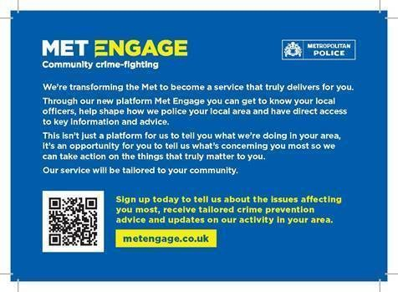

Through our new platform Met Engage you can get to know your local officers, help shape how we police your local area and have direct access to key information and advice.

This is not just a platform for us to tell you what we are doing in your area, it's an opportunity for you to tell us what's concerning you most so we can act on the things that truly matter to you.

https://www.metengage.co.uk/



YOU CAN STILL CONTACT US AS BELOW

Team Members

Based at Enfield Patrol Base your

Dedicated Ward Officers (DWOs) on

Ridgeway Ward are:

Supervisor

PS Alex Kane

Dedicated Ward Officers:
PC Todd Matthew

PCSO Deb Anjan

PCSO Agachi Simona

Email: ridgeway@met.police.uk

If you wish to report a crime you must always use
101 for non-emergency matters.
Always dial 999 in an emergency.

Useful Contacts
24/7 Police Station
Edmonton Police station
462 Fore Street, Edmonton N9 0PW

